**FOR USA HIRES ONLY:** This list is compiled for new hire convenience (first week task) and is not meant to be inclusive of all Cisco tasks. Please note that all of the links are only accessible after you have access to Cisco’s network and many links are only accessible in Internet Explorer. For detailed tasks, please visit [New Employee Roadmap](http://www.cisco.com/c/r/team-development/FYE/EN/new-employee-roadmap.html).

**Work Location Update**: You need this for your phone extension # request. Please update your [site location](https://ibpm.cisco.com/wpr/loc/login/GMyLBHa-hiqxmT09uQqBQw%5B%5B*/!STANDARD) on day 1.

**New Hire Orientation**: You have been automatically registered for orientation and will receive an email within the first two weeks of your start date. Please check if the session works for you. Charges will apply if the course is not rescheduled/dropped two weeks in advance. If you are unable to attend, you must drop this session and re-register for other available session here: [New Employee Orientation](http://www.cisco.com/c/r/team-development/FYE/EN/new-employee-orientation.html).

**Badging:** If you’re located at the following 3 major Cisco sites, please visit the security office to apply for your new badge. Major sites listed [here](http://wwwin.cisco.com/c/cec/organizations/finance/treasury/ssbr/sas/client-services.html).

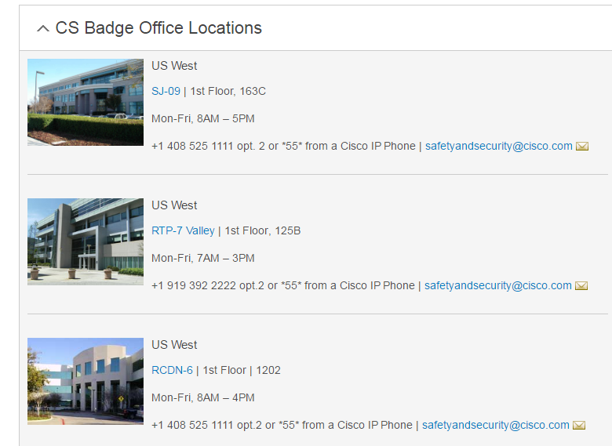

* If you are a vendor converting to a regular Cisco employee, your current red badge will stop working on your first day. Please visit badging to get a new badge or contact the nearest Cisco office lobby ambassador to obtain a temporary badge.
* For most sites, usually the local Cisco office lobby ambassador is the badge photographer. After a picture is taken with them, complete the online badging request form. Please check the following [locations](https://cisco.jiveon.com/docs/DOC-108429) and connect with the lobby ambassador to find out if they’re the badge photographer.
* For remote locations, badge needs to be arranged in advance. The list of remote locations as well as the form to order the badge can be found here: [Global Badging Link](http://wwwin.cisco.com/security/sas/badging/obtain/) . If you need further assistance, submit an inquiry [here](http://wwwin.cisco.com/security/sas/requestform.shtml).

**Form I-9 (US Federal Form)**

* Complete your I-9 form and verification within 3 days after new hire start date. Please follow the I-9 info kit that is attached in your welcome email along with this new hire checklist.
* Contact I-9 team if you need further help or have other questions: [employeei9@cisco.com](mailto:employeei9@cisco.com)
* For more information, please visit the I-9 jive page when you gain your Cisco internal access: <https://cisco.jiveon.com/groups/i-9/pages/home>

**Employee address and profile: For 1st paycheck mailing:**

* Verify your address. 1st payroll check will be mailed to address in profile. Go [here](http://wwwin.cisco.com/c/cec/index.html) and follow steps below. It may take 48 hours from start date to gain access to this portal.

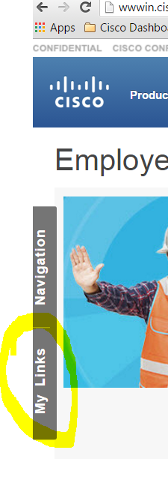 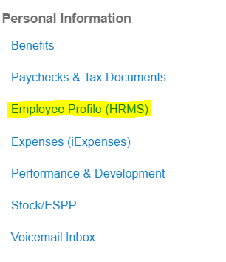

If your access is not yet granted for you to verify your address, please contact People Support (HR) during your 1st week to ensure payroll has the correct address. If you moved after you have completed all offer paperwork, most likely payroll has your old address. HR Support will need to manually update the record for you. HR Support Phone # is listed on the last page of this document.

**Payroll:** Cisco utilizes [Payroll Workcenter](http://wwwin.cisco.com/c/cec/employee/pto-payroll.html) for all payroll needs (eg. Submitting W4/direct deposit setup)

Payroll site is not accessible on 1st day (the system will not recognize new hire login). Sync up takes several days and depends on your start date within payroll cycle.

* Access is usually granted within 1-2 pay periods (usually between 4-10 days from your start date). Please try daily.
* Once access is granted, you can sign up for direct deposit and complete W4/State tax elections. Until this access has been given, you will receive a live check which will be mailed to the address on file via USPS First Class Mail.
* First paycheck is paper check and tax elections will default to single and 0. You will update subsequent paycheck delivery option & tax election through Payroll WorkCenter. Please contact the HR Support (Phone # listed on last page) if you have any additional questions.
* Complete W4 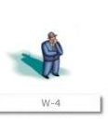 (NOT W2).
* Alternatively, Payroll Workstation is also accessible via [here](http://wwwin.cisco.com/c/cec/index.html). Follow this path: CEC-MyLinks-Paychecks & Tax Documents.

**Payroll calendar:** Follow the steps to add [payroll & holiday calendar](https://cisco.jiveon.com/docs/DOC-974125) to your Outlook calendar.

For additional payroll and payroll calendar information, please click on this [link](http://wwwin.cisco.com/c/cec/employee/pto-payroll/us/tools.html).

**BENEFITS:** Access it [here](http://wwwin.cisco.com/c/cec/employee/benefits-comps.html): select your region to enroll your Health Benefits, 401k, etc. under Explore Benefits.

* Benefit coverage starts at day 1. New hire will have **30 days** to make selection and all benefit data is provided online.
* For spouse/family members/dependents: visit this [page](http://www.myciscobenefits.com).

**Employment Verification:**

Employees can self-generate a verification of employment letter by accessing the HRMS Employee Self Service tool. This tool can be accessed from [here](http://wwwin.cisco.com/c/cec/index.html). Follow this path: CEC->my links->Employee Profile (HRMS)

Once logged in HRMS, select All Other Tasks -> US – Employee Services, Cisco US -> Verification of Employment and complete the form request.

**3rd party verification request**: bank, mortgage, credit card, rental, etc.:

Cisco has contracted with The Work Number to respond to all employment and wage inquiries regarding current or former Cisco employees. If you are applying for a loan, mortgage, credit card, apartment lease, etc. you should instruct your lender to contact The Work Number at 1-800-367-2884 (Employer 5 digit code: 10157).

You can also provide information to 3rd party through salary key. Follow this [instruction page](https://hrckm.cisco.com/InfoCenter/index?page=content&id=FAQ3032&actp=search&viewlocale=en_US&searchid=1478048586508#http://www.theworknumber.com/) and visit [Employment Verification](http://www.theworknumber.com/Employees/).

**Other Frequently Asked Info:**

* [Mobile Phone](https://cisco.jiveon.com/groups/it-mobility)
* [American Express card application](http://wwwin.cisco.com/c/cec/support/amex.html)
* [Booking travel](http://wwwin.cisco.com/c/cec/organizations/cisco-services/ts/tso/gtc/cin/agent/cfl/corporateinfo/transfertravel.html)

Find many answers to your questions through Cisco portal: helpzone.cisco.com

If you are still unable to find answers to your question, you may contact People Support from Helpzone portal via the Click2Chat or opening a case.

Phone support is available for both HR Support and Technical Support. Visit this URL for the available telephone numbers: <http://helpzone.cisco.com/t5/custom/page/page-id/PhoneSupport>